NATIONAL UNIVERSITY OF MODERN LANGUAGES
Program fundamental assignment # 02

SUBMITTED BY:
ZULQARNAIN HASSAN

SUBMITTED TO:
SIR AAQIB ADEEL
System ID: NUML-S22-15676
Faculty: Engineering and computer science
Department: Software engineering
Section: BSSE-1-A-afternoon
Q#1: What are ASCII values? Why are they important? Write a program that displays the ASCII values of characters.
ASCII values:
The numerical value, or order, of an ASCII character. There are 128 standard ASCII characters, numbered from 0 to 127. Extended ASCII adds another 128 values and goes to 255. The numbers are typically represented in decimal or in hexadecimal.
Importance of ASCII values:
All computers speak in binary, a series of 0 and 1. However, just like English and Spanish can use the same alphabet but have completely different words for similar objects, computers also had their own version of languages. ASCII is used as a method to give all computers the same language, allowing them to share documents and files.
ASCII is used to translate computer text to human text.
A program that displays the ASCII values of characters:
#include<iostream>
using namespace std;
main ()
{
char first,second;
cout<<"Enter two characters : ";
cin>>first;
cout<<"ASCII value of "<<first<<" is = "<<first;
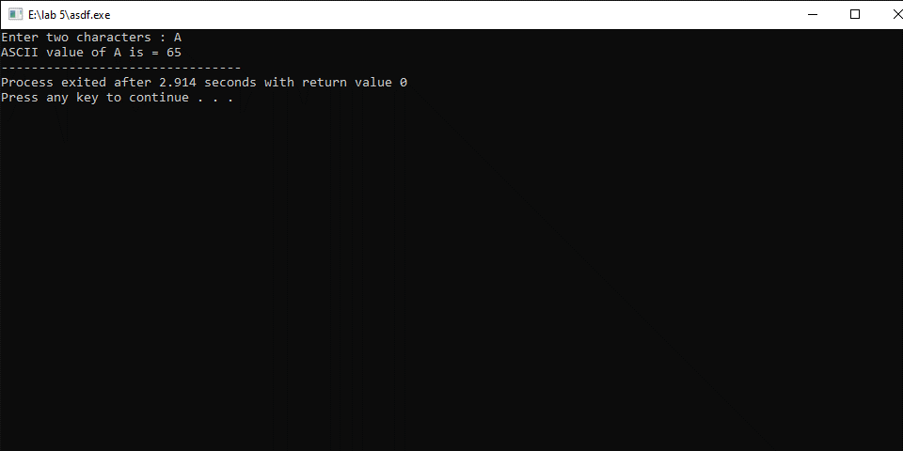
}

Q#2: What is the difference between break and continue statements? Explain with coding examples?
Parameters | Break Statement in C | Continue Statement in C
Loop Construct | This statement lets a user exit from an overall loop construct. | It does not let a user make an exit from an overall loop construct.
Switch and Loop Statement | One can easily use the break statement along with the switch statement. You can also use it within the for loop, do-while loop, and the while loop. It means that break can easily occur in both loop and switch. | You cannot use the continue statement with the switch statement. Still, you can use it within the for loop, do-while loop, and the while loop. It means that continue can only occur in the loop and not switch.
Control | The control exits immediately from a loop construct as soon as it encounters the break statement. | As soon as the control encounters the continue statement, it passes automatically from the very beginning of a loop statement.
Function | The break statement causes a loop or a switch to terminate a case at the very moment of its execution. It means that a switch or a loop would end abruptly as soon as they encounter a break. | The continue statement doesn’t cause a loop termination- but leads it into its next iteration. It means that a loop will execute all of its iterations even if it encounters a continue statement. We use the continue statement to skip those statements that appear after the continue in a loop.
Syntax | You can denote it as:  break; | You can denote it as:  continue;

Example for break:
#include<iostream>
using namespace std;
main ()
{
for (int i = 0; i < 10; i++)
{
if (i == 4)
{
break;
}
cout << i << "\n";
}
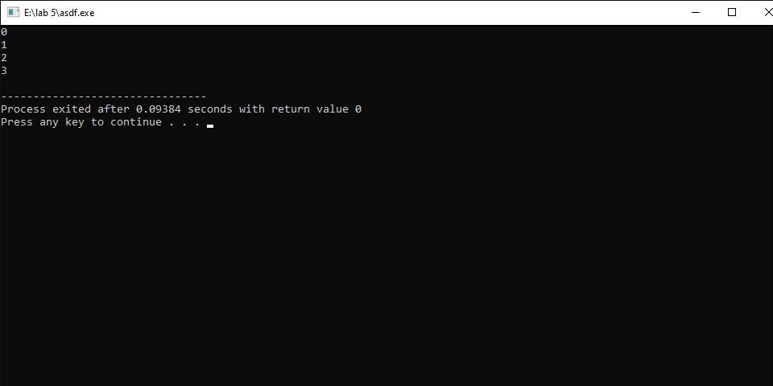
}

Example for continue:
#include<iostream>
using namespace std;
main ()
{
for (int i = 0; i < 10; i++)
{
if (i == 4)
{
continue;
}
cout << i << "\n";
}
}
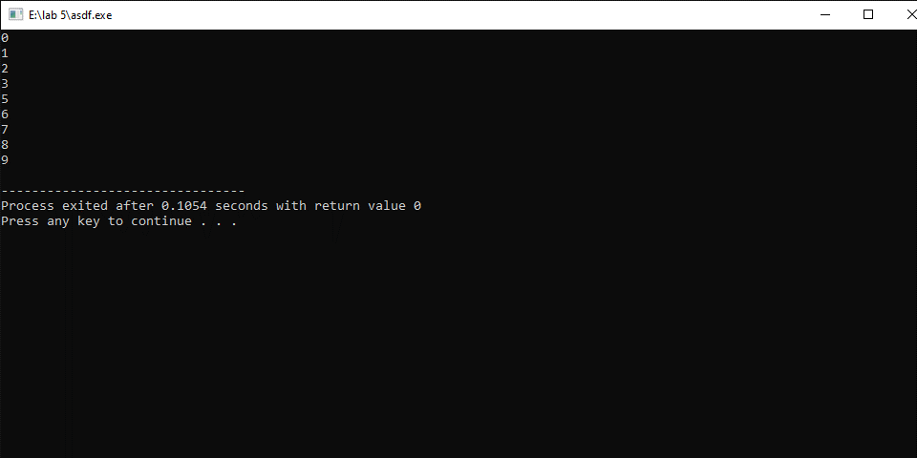
Q#3: What is the difference between Unary, binary, and ternary operators? Explain with coding examples.
Unary:
Unary operators perform an action upon a single operand.
Binary:
Binary operators perform an action upon two operands.
ternary:
Ternary operators perform an action involving three operands.
Example:
#include<iostream>
using namespace std;
main ()
{
int n1,n2;
cin>>n1>>n2;
n1+=n2;
n2++;
n1--;
cout<<"n1= "<<n1<<"\nn2= "<<n2;

}
